Automated Railway System and Rail Break Detector

**Group Number: 6**

**Group Members:**

1. R. Shiva Sai Charan
2. M. Abhiram
3. D. Chandrahaas
4. Y. Narendra Reddy
5. D. Praveen Kumar
6. B. Surya Sowri

# Abstract

Railways is the biggest network in India. Damage to railways brings down India’s economy drastically down. We come across many rail accidents, also train drivers suffer a lot during night drives. To help them and to prevent such happenings we come with a noble idea.

Justification and the Novelty

1. Rail Accidents.
2. Train delay.
3. Difficulty for drivers in foggy and mist conditions.
4. Rail Breaks

# Rail Breaks

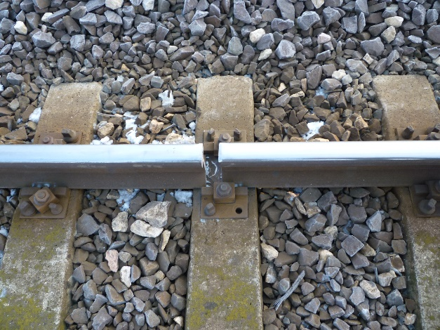 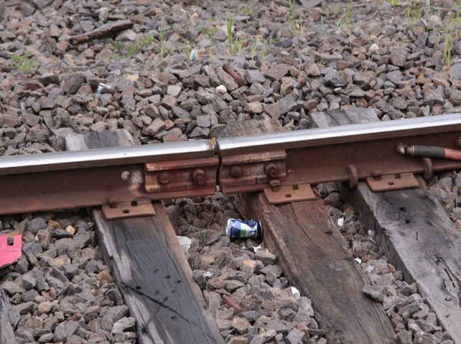

# Rail breaks are a great threat to railway systems. In order to check it, we have a system to find and intimate to local service men and inform them about it.

# Fog and misty conditions

We see many accidents taking place in foggy, rainy and in misty conditions. We come with such an idea to reduce them to a great extent.

# Functional Block Diagram

Signal and information

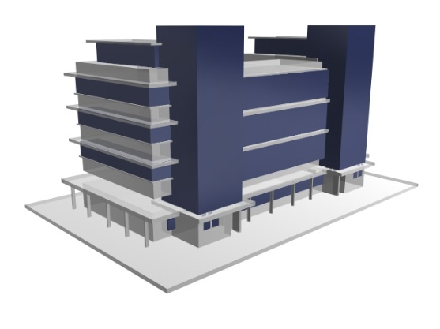 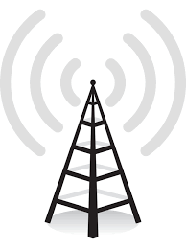

Alerts officers about rail break

Send information to trains

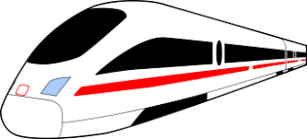

Informs about rail break

## Hardware Requirements

1. Arduino (4) (we have them)
2. NRF24L01 2.4 GHz Transceiver module (Rs.800->4*200)
3. A car module (assumed to be train) (lab’s having them )

# nRF24L01 – 2.4GHz RF Transceiver Module

### **Description:**

These RF modules are very popular among the Arduino tinkerers. The nRF24L01 is used on a wide variety of applications that require wireless control. They are transceivers which this means that each module can transmit and receive data.

**Specifications:**

1. Low cost single-chip 2.4GHz GFSK RF transceiver IC
2. Range with Antenna: 250Kb rate (Open area) >1000 meter
3. Power: Ultra low power consumption
4. Input Voltage: 3.3V
5. Pins: 5V tolerant

**Data Packets:**

The nRF24L01+ modules can transmit a maximum of 32 bytes in a single message. If you need to send more you will need to break it into a number of separate messages. For this tutorial I will not be sending more than 32 bytes. We can also change the payload size with setPayloadSize().We can check the payload size with getDynamicPayloadSize()

**Connections:**

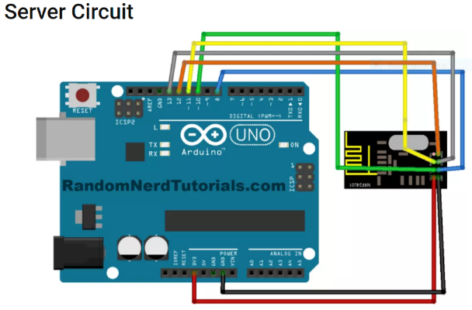 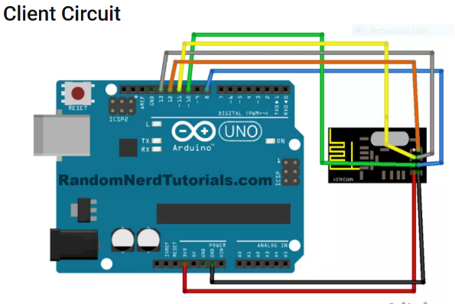

# IC Motor Driver (L293D)

# 

**Working:**

L293D is a dual [H-bridge](http://www.engineersgarage.com/electronic-circuits/h-bridge-motor-control) motor driver integrated circuit (IC). Motor drivers act as current amplifiers since they take a low-current control signal and provide a higher-current signal. This higher current signal is used to drive the motors.

L293D contains two inbuilt H-bridge driver circuits. In its common mode of operation, two DC motors can be driven simultaneously, both in forward and reverse direction. The motor operations of two motors can be controlled by input logic at pins 2 & 7 and 10 & 15. Input logic 00 or 11 will stop the corresponding motor. Logic 01 and 10 will rotate it in clockwise and anticlockwise directions, respectively.

Enable pins 1 and 9 (corresponding to the two motors) must be high for motors to start operating. When an enable input is high, the associated driver gets enabled. As a result, the outputs become active and work in phase with their inputs. Similarly, when the enable input is low, that driver is disabled, and their outputs are off and in the high-impedance state.

**Pin Diagram:**

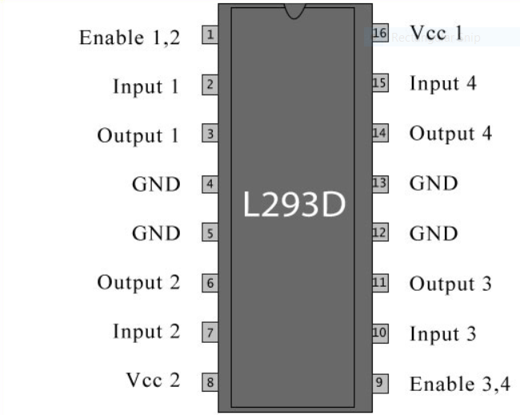

### **Pin Description:**

